**INFORMATICA POWERCENTER ASSIGNMENT**

**Assignment A :**

CREATE TABLE STUDENT_SRC(Student_ID INT, Student_Name VARCHAR(50), Math_Score INT, Phy_Score INT, Chem_Score INT);

INSERT INTO STUDENT_SRC VALUES(10,’Student 1’,80,66,90);

INSERT INTO STUDENT_SRC VALUES(20,’Student 2’,52,71,48);

INSERT INTO STUDENT_SRC VALUES(30,’Student 3’,76,73,76);

INSERT INTO STUDENT_SRC VALUES(40,’Student 4’,96,89,72);

INSERT INTO STUDENT_SRC VALUES(50,’Student 5’,61,87,74);

INSERT INTO STUDENT_SRC VALUES(60,’Student 6’,70,55,85);

INSERT INTO STUDENT_SRC VALUES(70,’Student 7’,77,52,81);

INSERT INTO STUDENT_SRC VALUES(80,’Student 8’,88,97,82);

INSERT INTO STUDENT_SRC VALUES(90,’Student 9’,82,49,93);

INSERT INTO STUDENT_SRC VALUES(100,’Student 10’,59,78,56);

* Find out “Top 3 students in the class” and write the data in a target flat file (Student_ID, Student_Name, Total_Marks, Rank) order by Rank (ASC).

Ans:

* Import source in Source Analyzer by Sources -> Import from database.

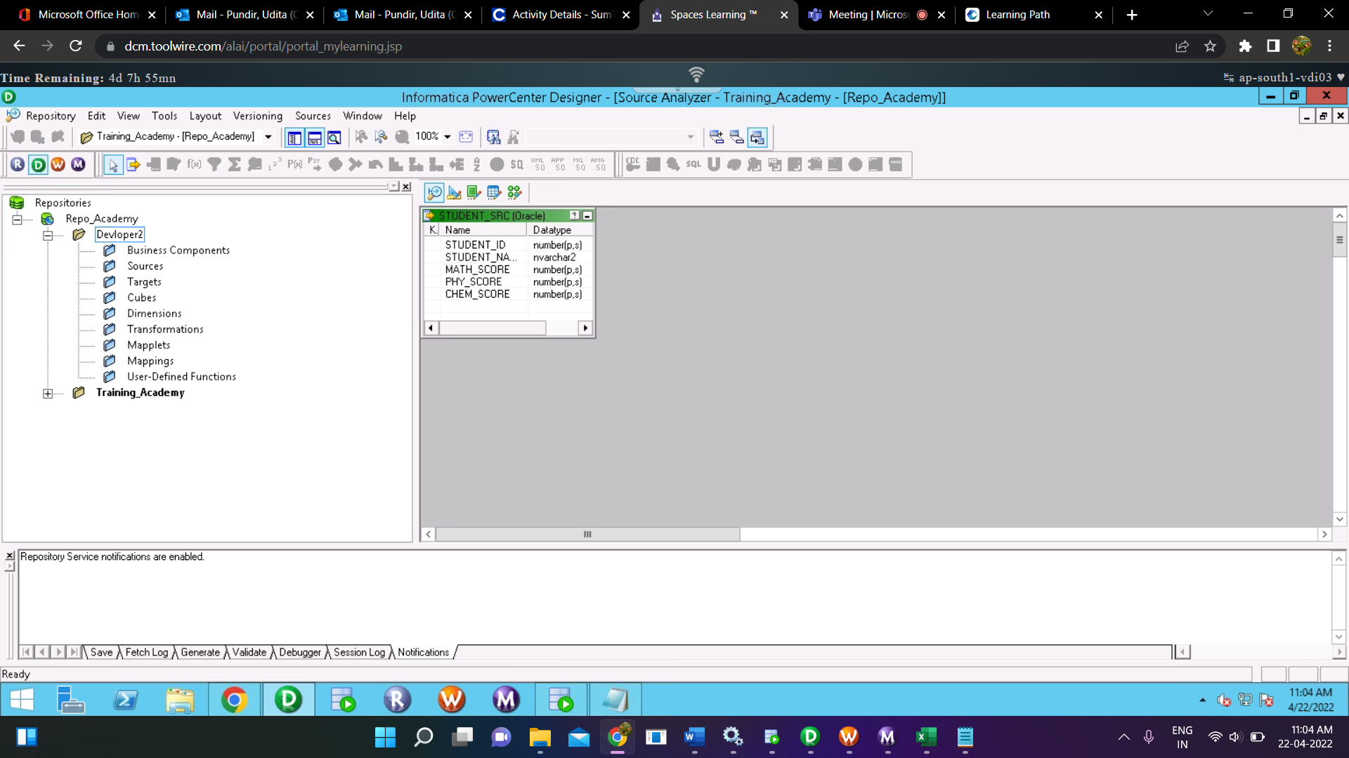

* Create a CSV file which will be a target flat file and import in target:

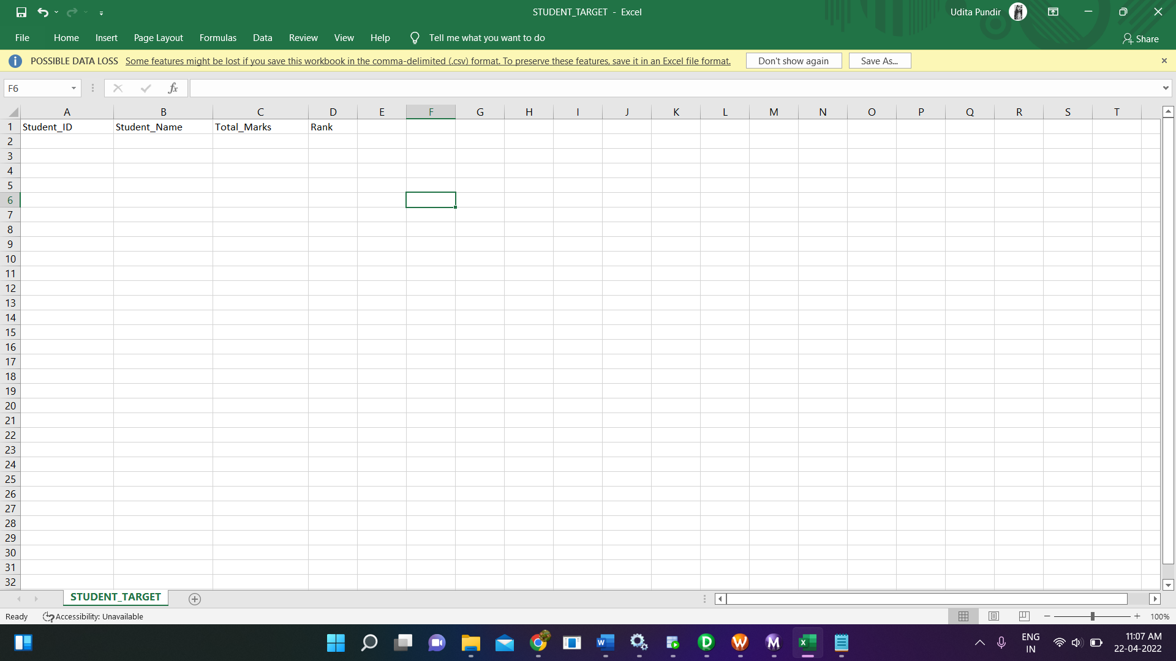

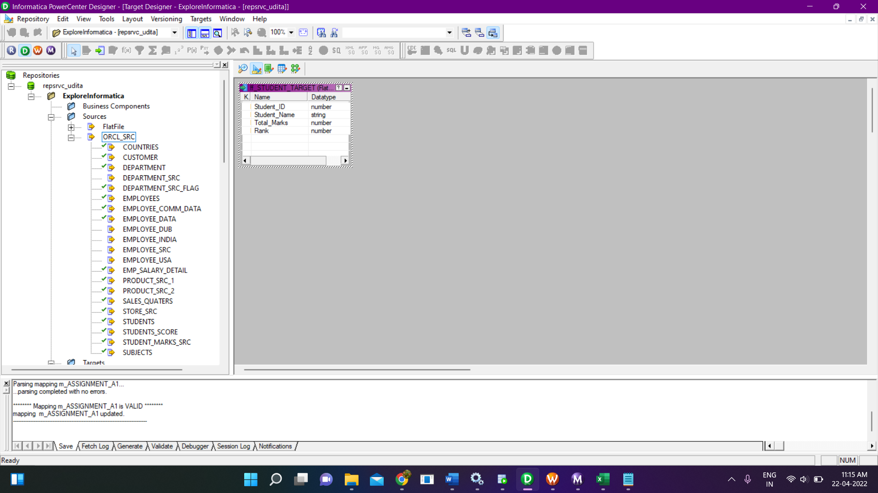

* Create a mapping name ‘m_AssignmentA1’ and drag source and target into the mapping and I’ll be using expression transformation for calculating Total_Marks and Rank_Transformation for finding the Rank and Sorter in order to sort the data.

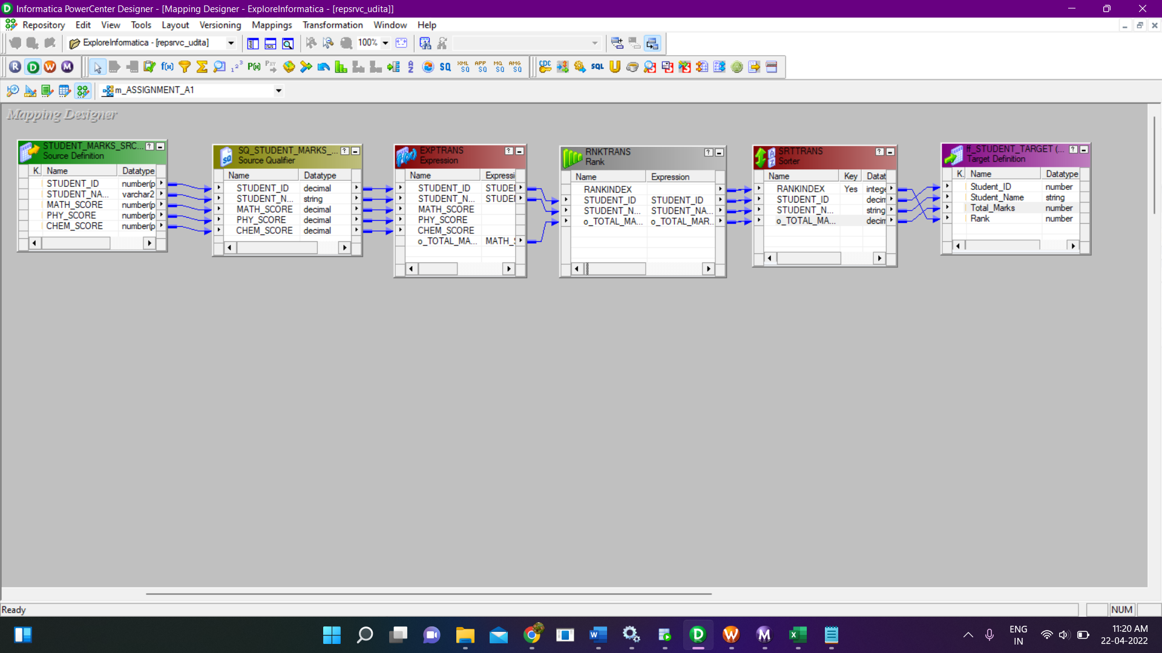

* Expression Transformation:

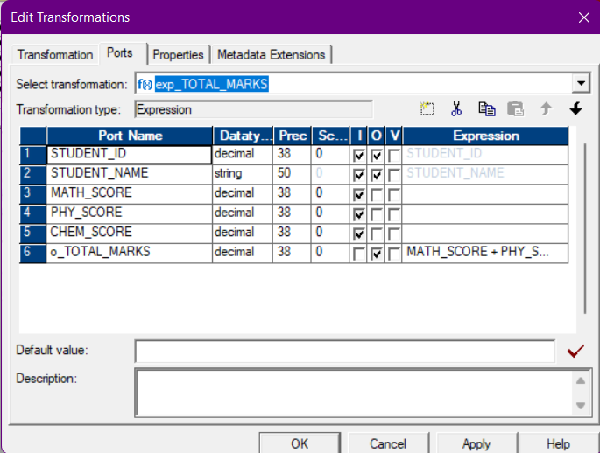

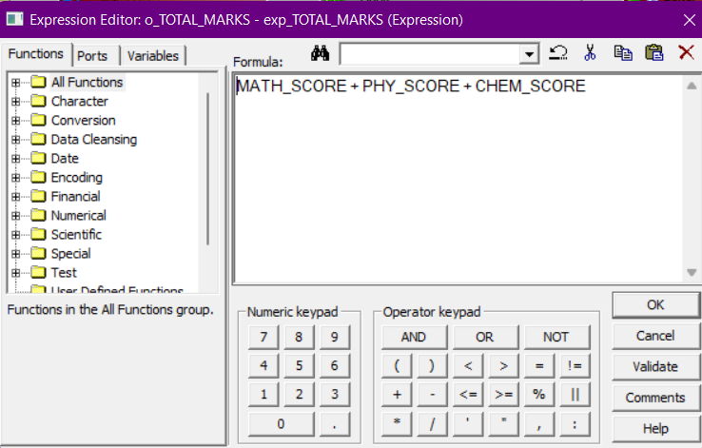

* Rank Transformation:

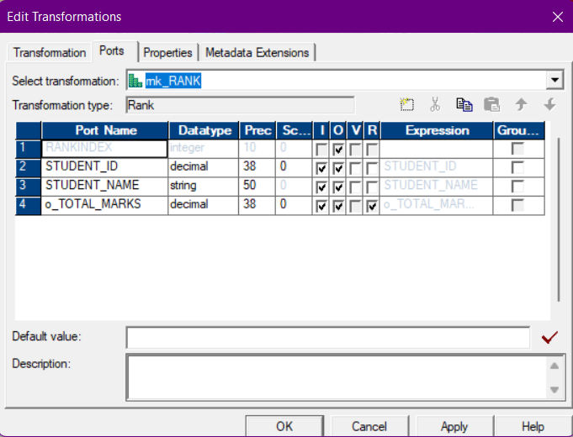

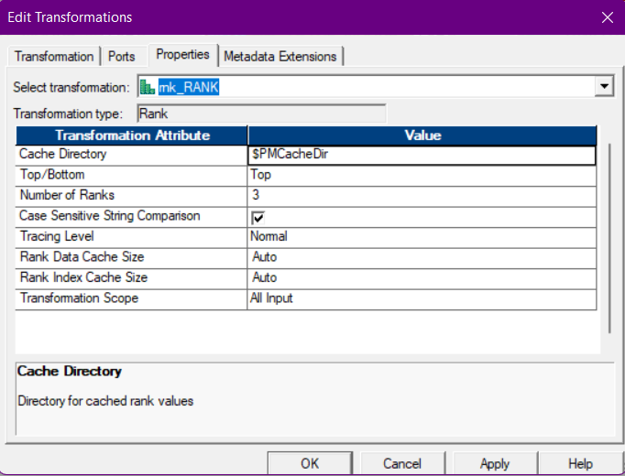

* Sorter:

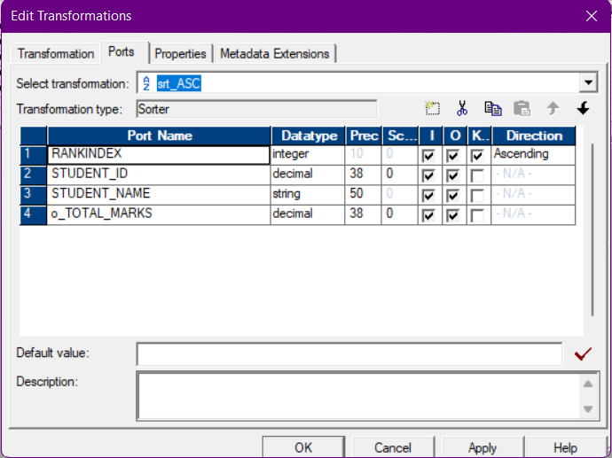

* Now, from sorter we will directly map to our target flat file as per column name.
* After creating mapping, we will create session and workflow, for creating session go to Task-> Create in the Task Manager.

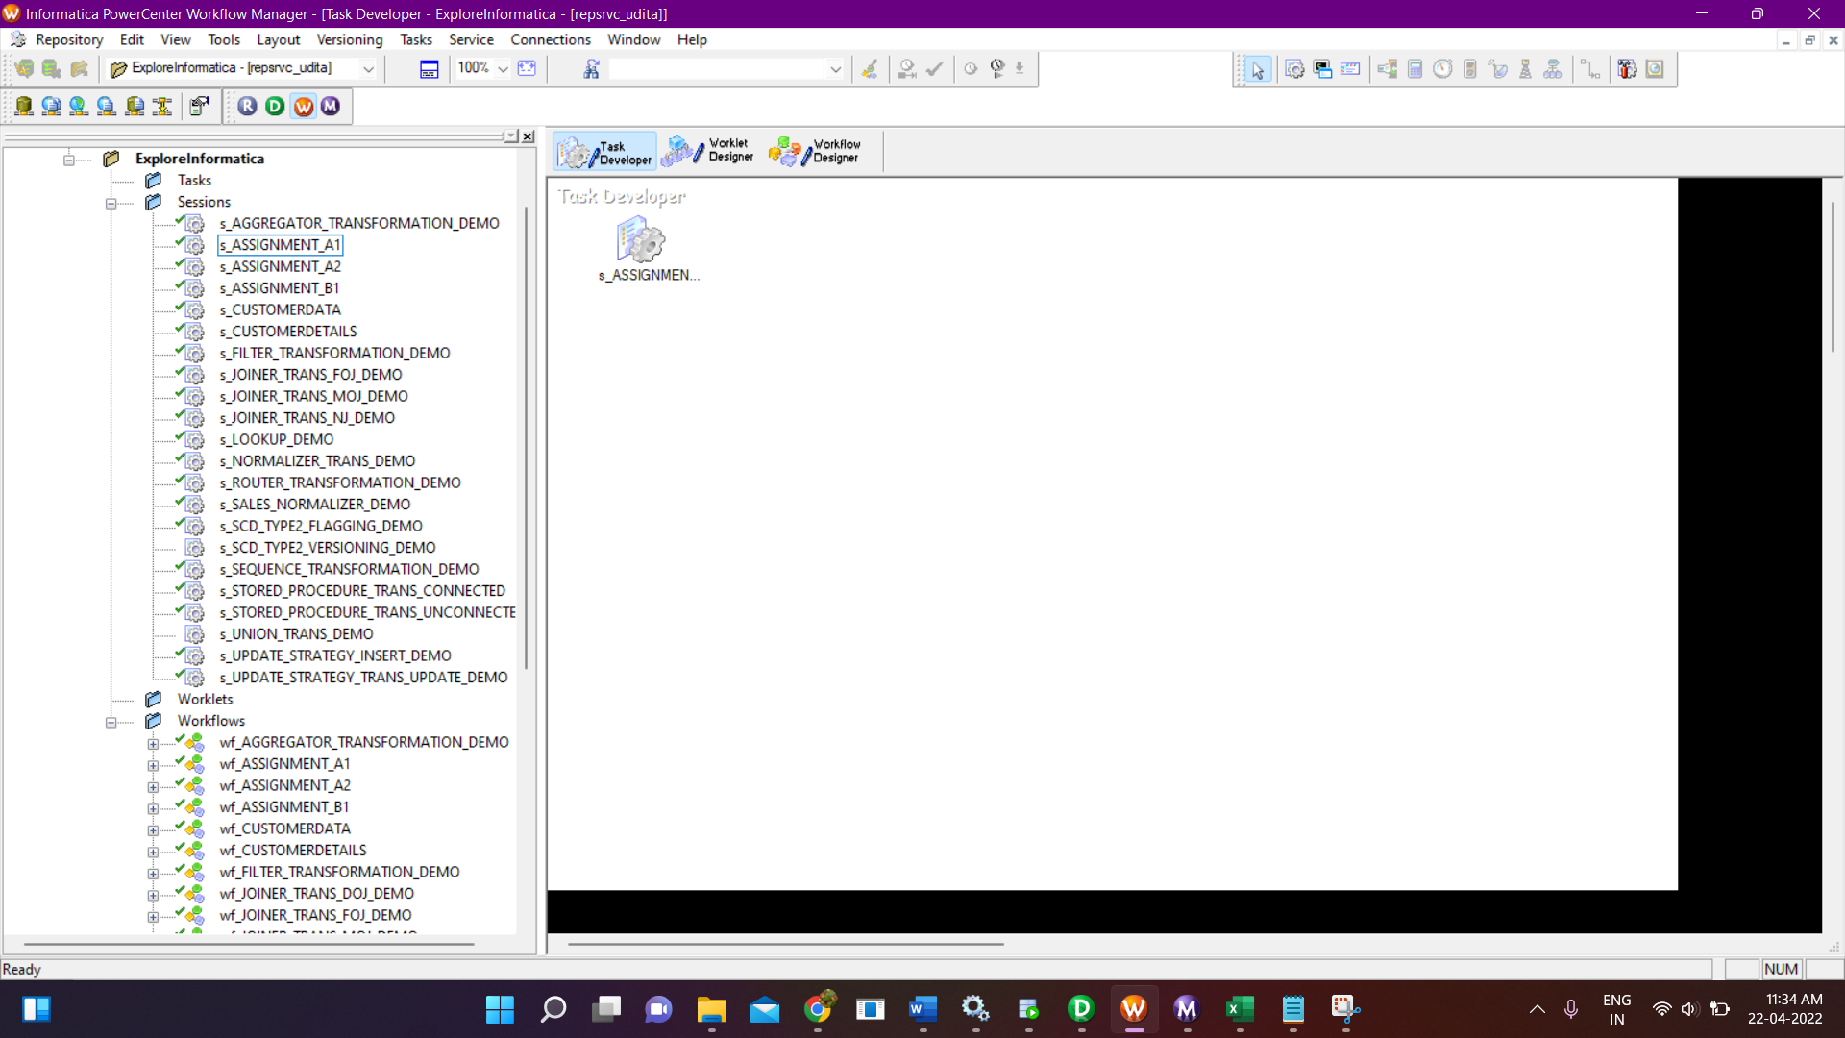

* Workflow:

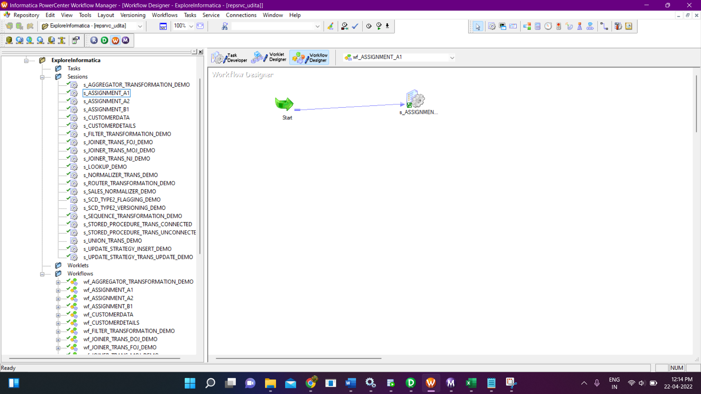

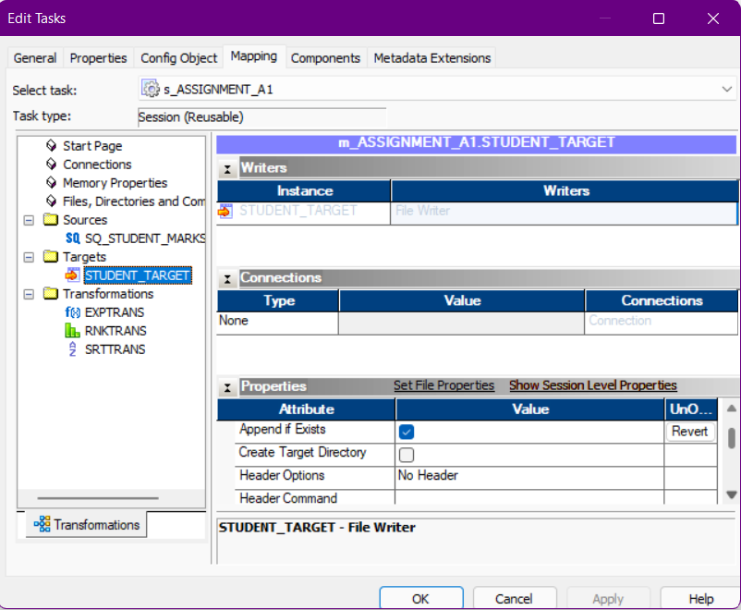

* Save all the changes and Right Click->Start Workflow.

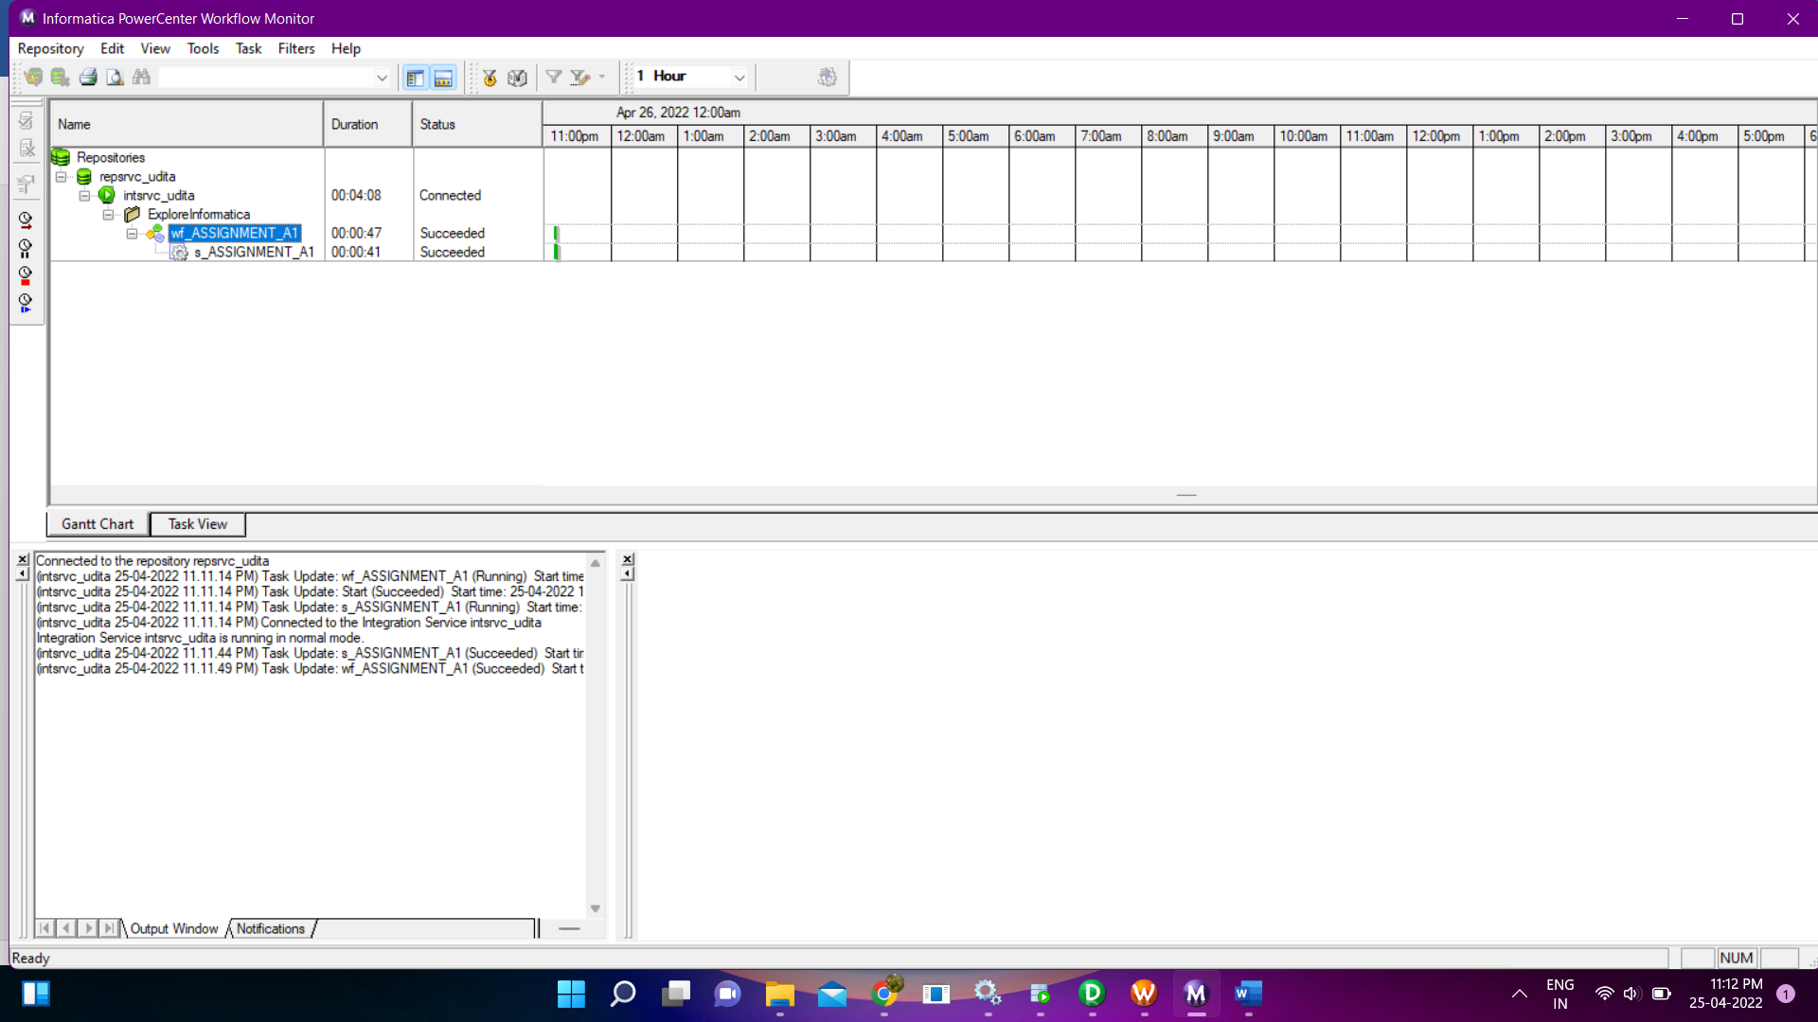

* Output:

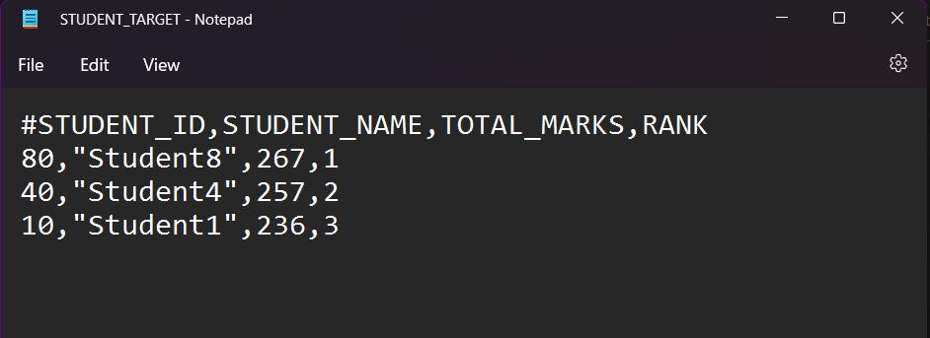

* Find out “Top 3 students in each subject” and write the data in another target flat file (Subject, Student_ID, Student_Name, Marks, Rank) order by Subject, Rank (ASC) .

Ans:

* Import source in Source Analyzer by Sources -> Import from database.



* Import Target in Target by Target -> Import from File.

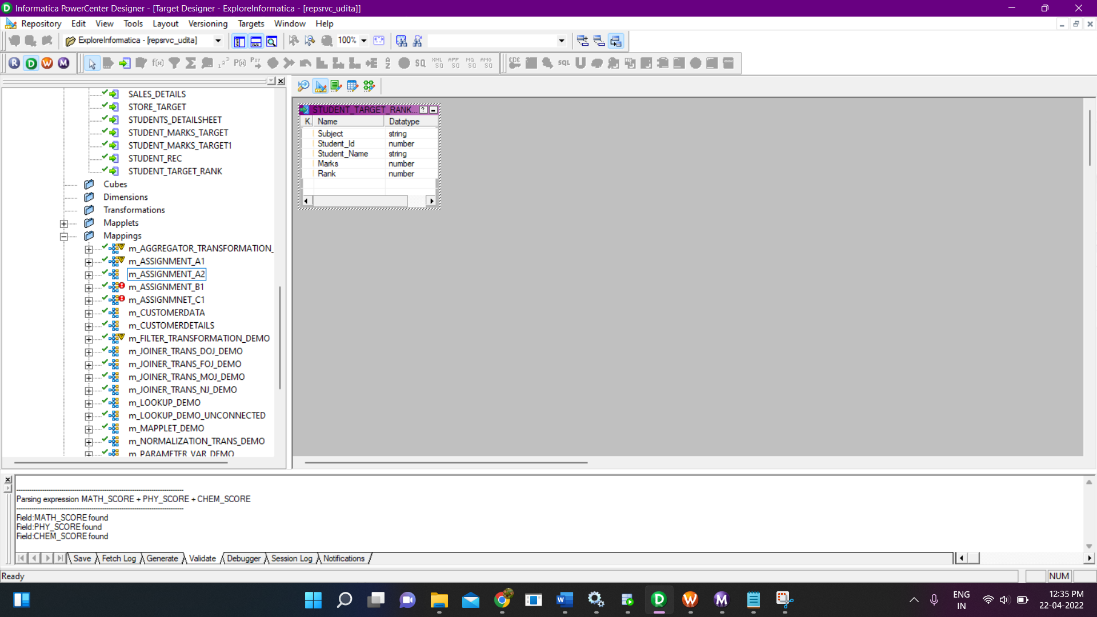

* Create a mapping name ‘m_AssignmentA2’ and drag source and target into the mapping and I’ll be using expression transformation for hard coding for subject names and Normalizer transformation and Rank_Transformation for finding the Rank and Sorter in order to sort the data.

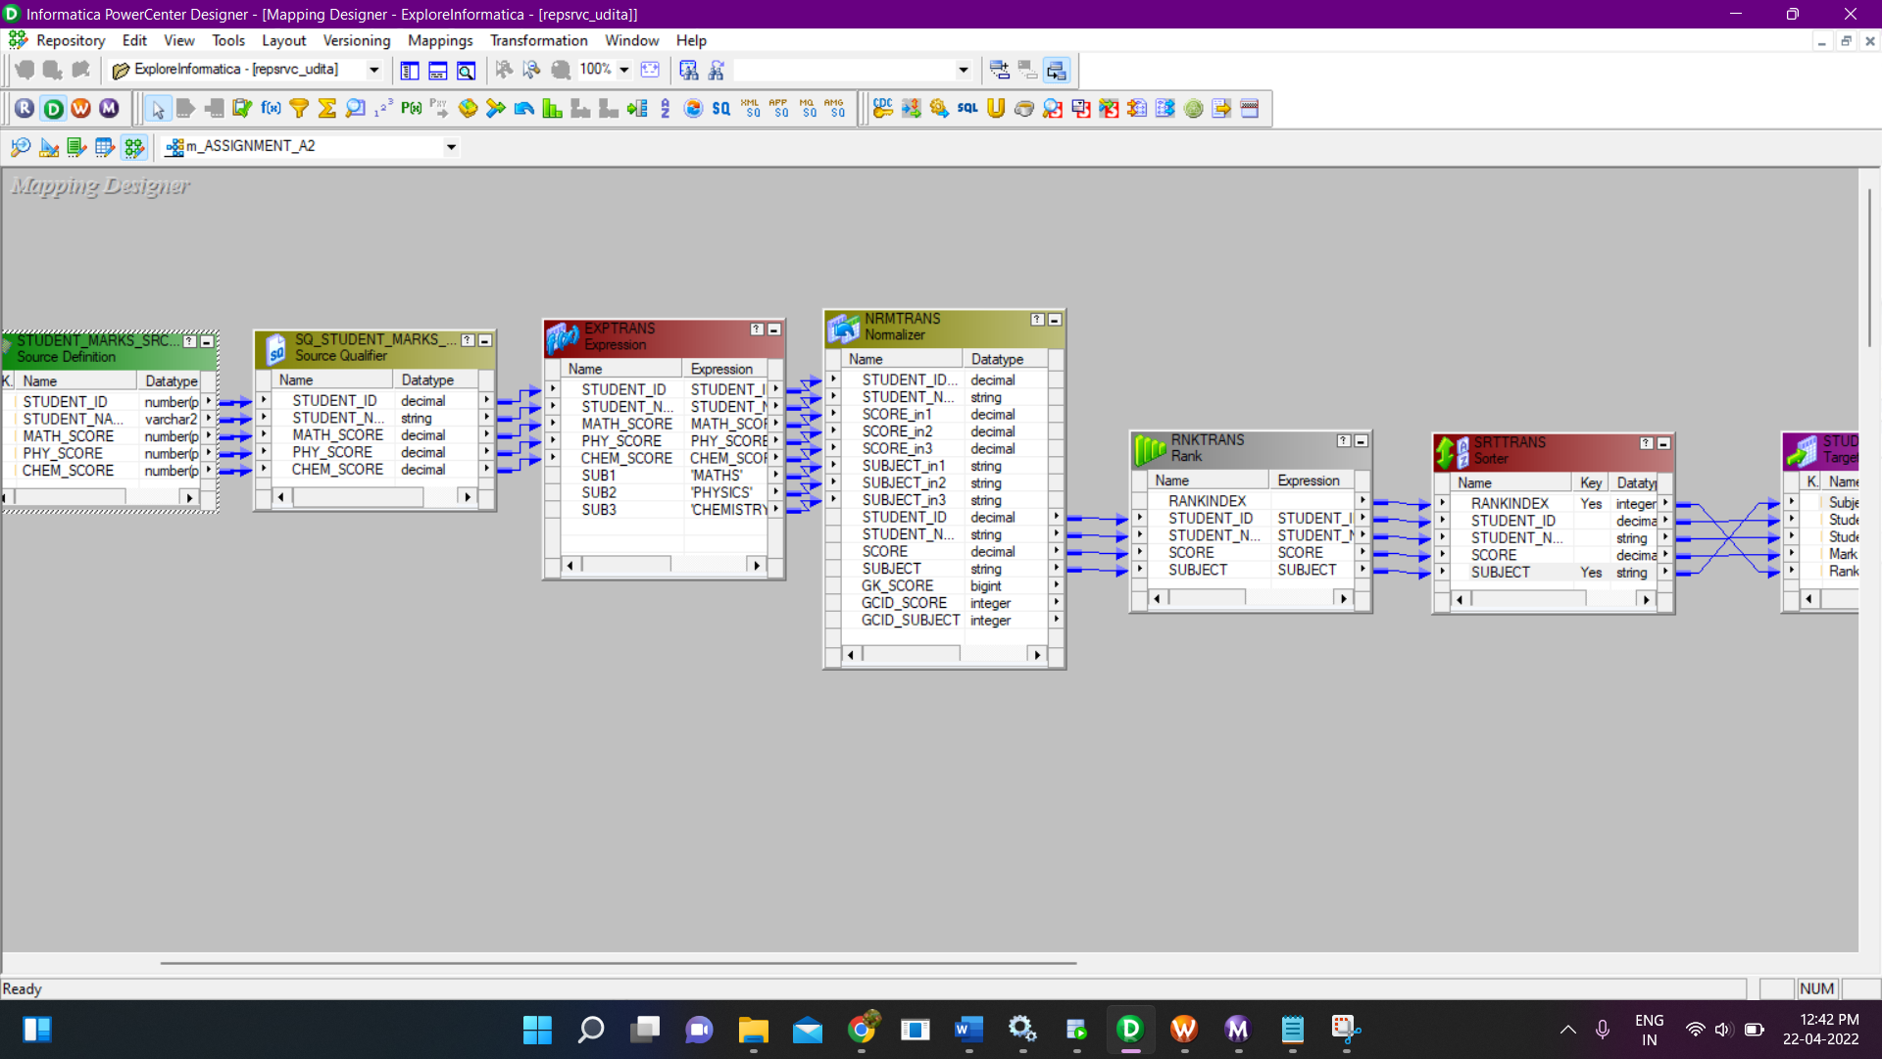

* Expression Transformation:

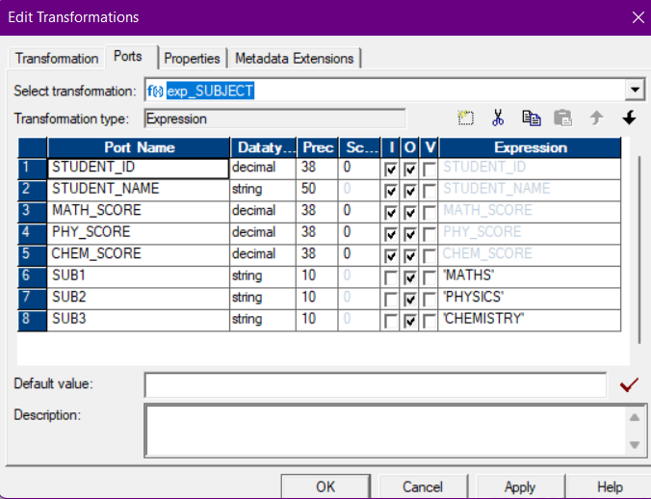

* Normalizer Transformation:

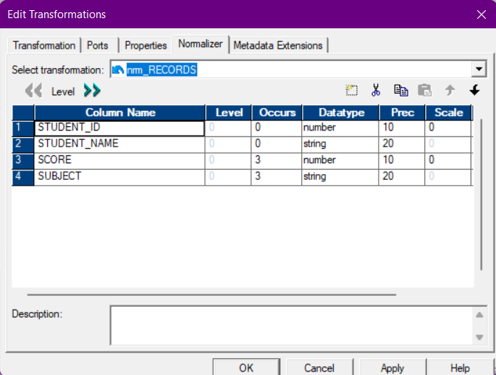

* Rank Transformation:

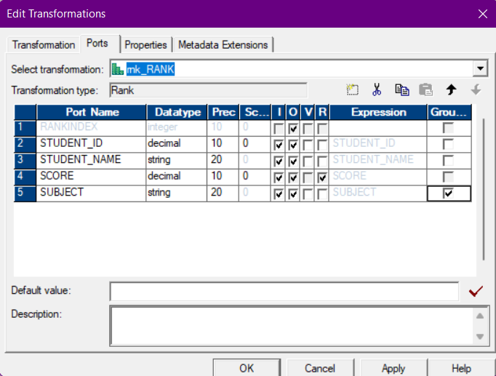

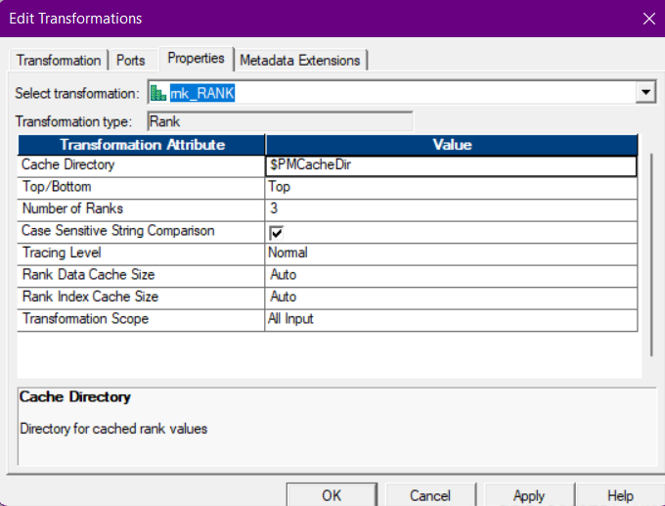

* Sorter Transformation:

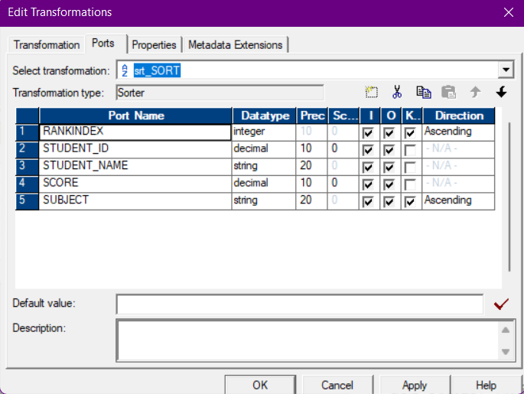

* Now, from sorter we will directly map to our target flat file as per column name.
* After creating mapping, we will create session and workflow, for creating session go to Task-> Create in the Task Manager.

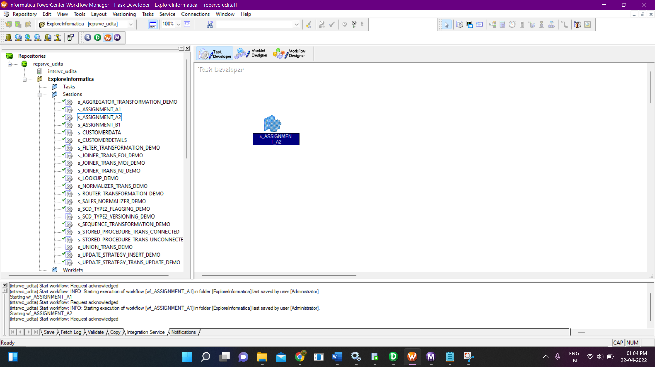

* Workflow:

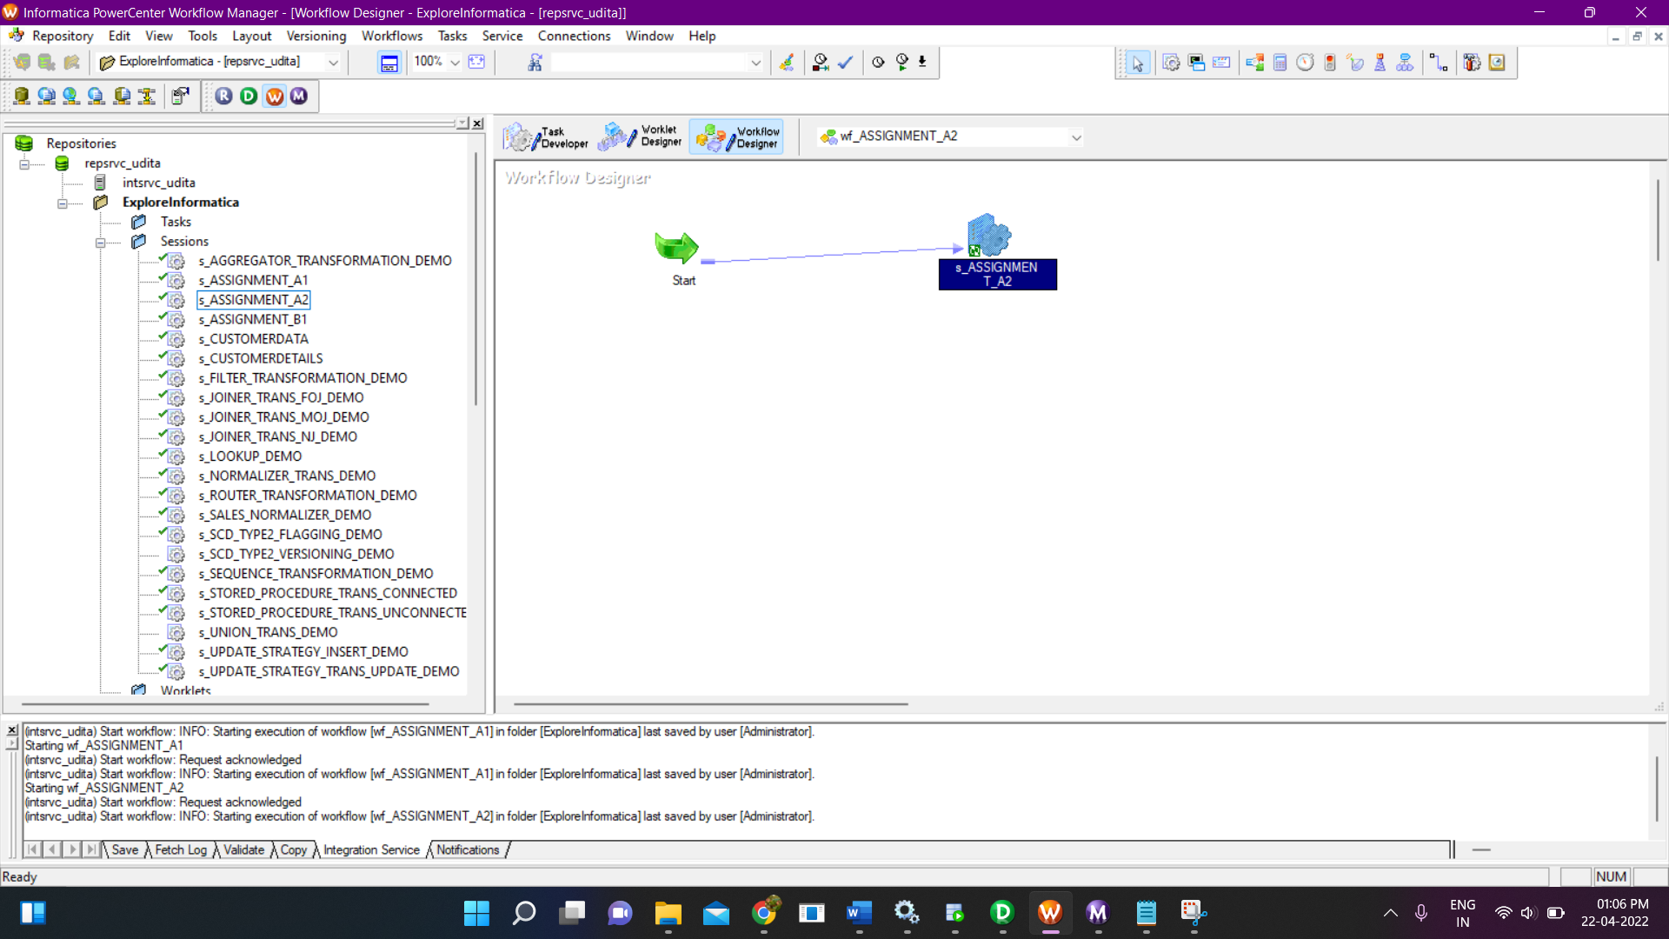

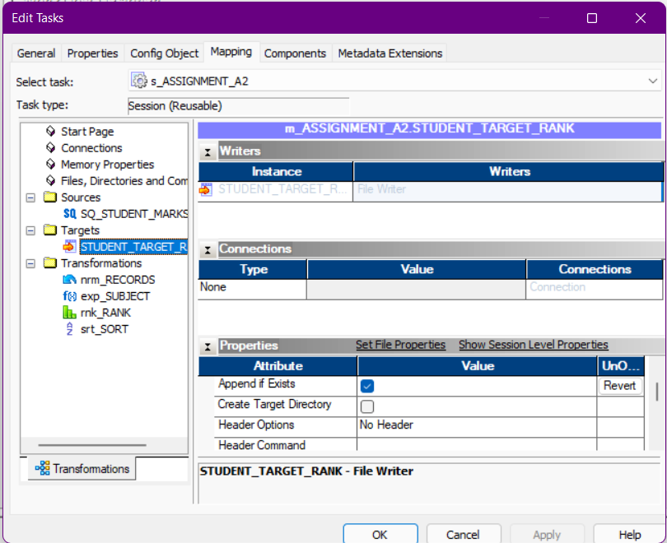

* Save all changes and Right click -> Start Worflow.

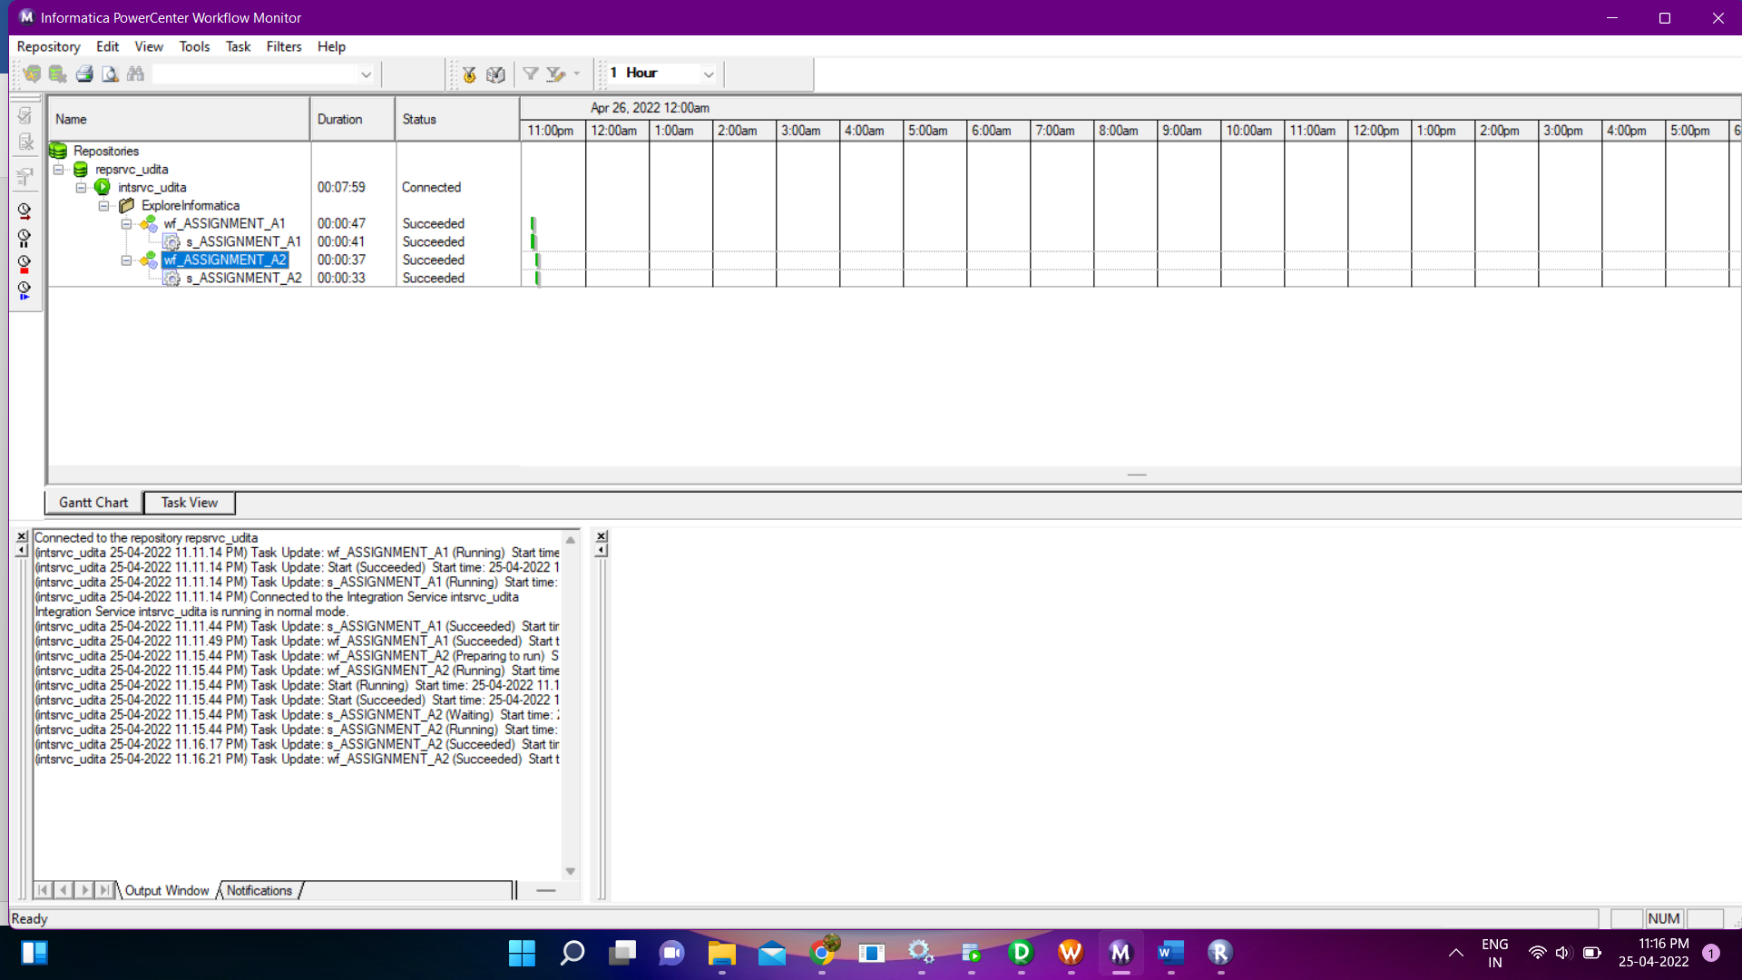

* Output:

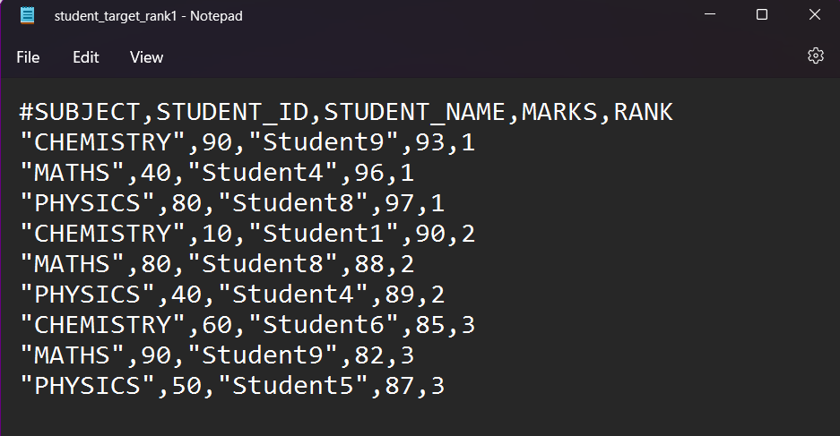

* Present the Source Data in Following format in a separate target file : (Student_ID, Student_Name, Subject (Values - Maths, Physics, Chemistry) , Marks

Ans

* Import source in Source Analyzer by Sources -> Import from database.



* Import Target in Target by Target -> Import from File.

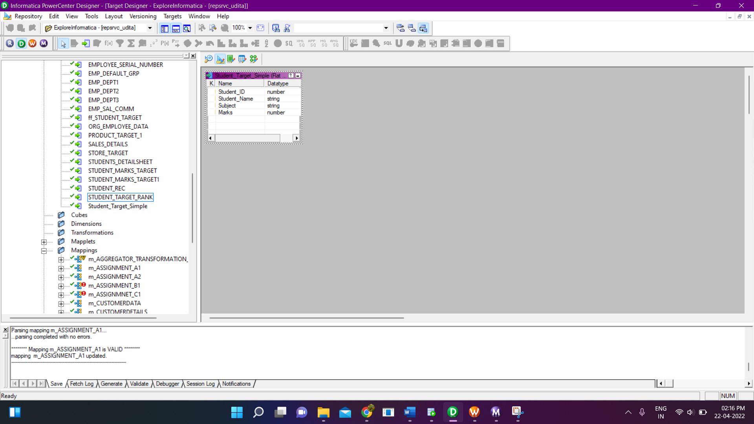

* Create a mapping name ‘m_AssignmentA3’ and drag source and target into the mapping and I’ll be using expression transformation for hard coding for subject names and Normalizer.

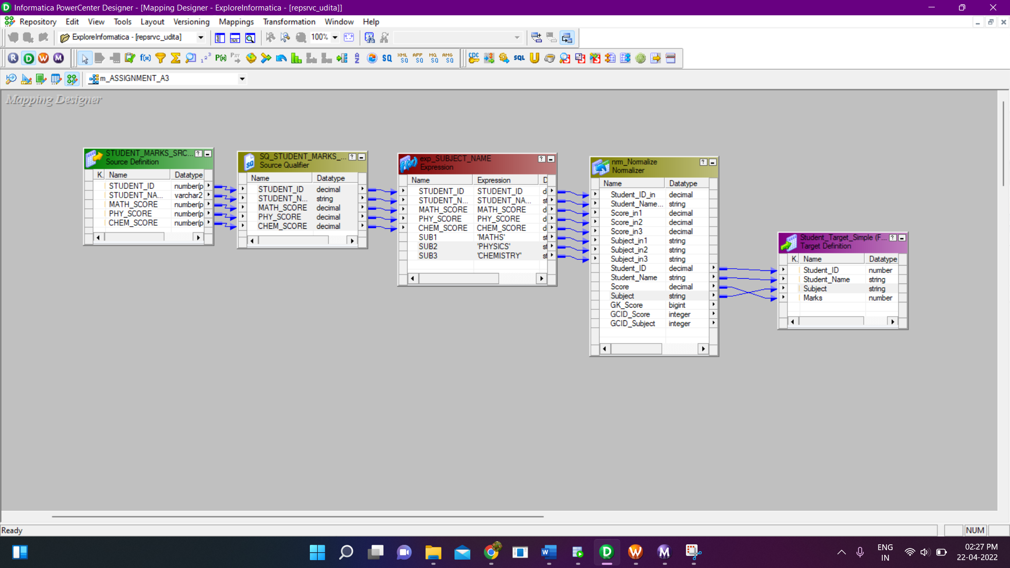

* Expression Transformation:

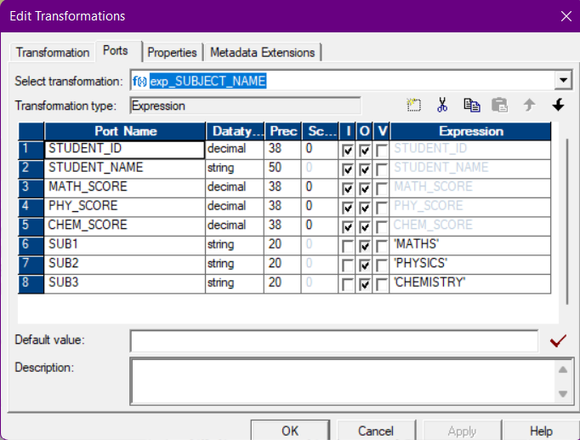

* Normalizer Transformation:

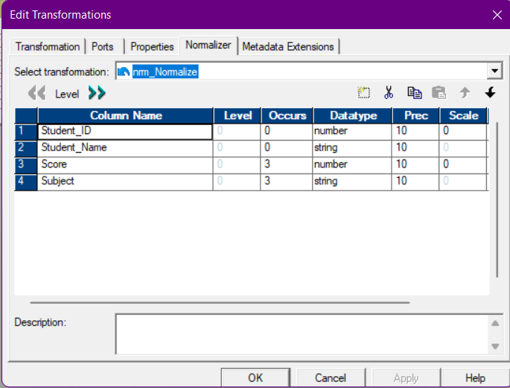

* Now, from Normalizer Transformation we will directly map to our target flat file as per column name.
* After creating mapping, we will create session and workflow, for creating session go to Task-> Create in the Task Manager.

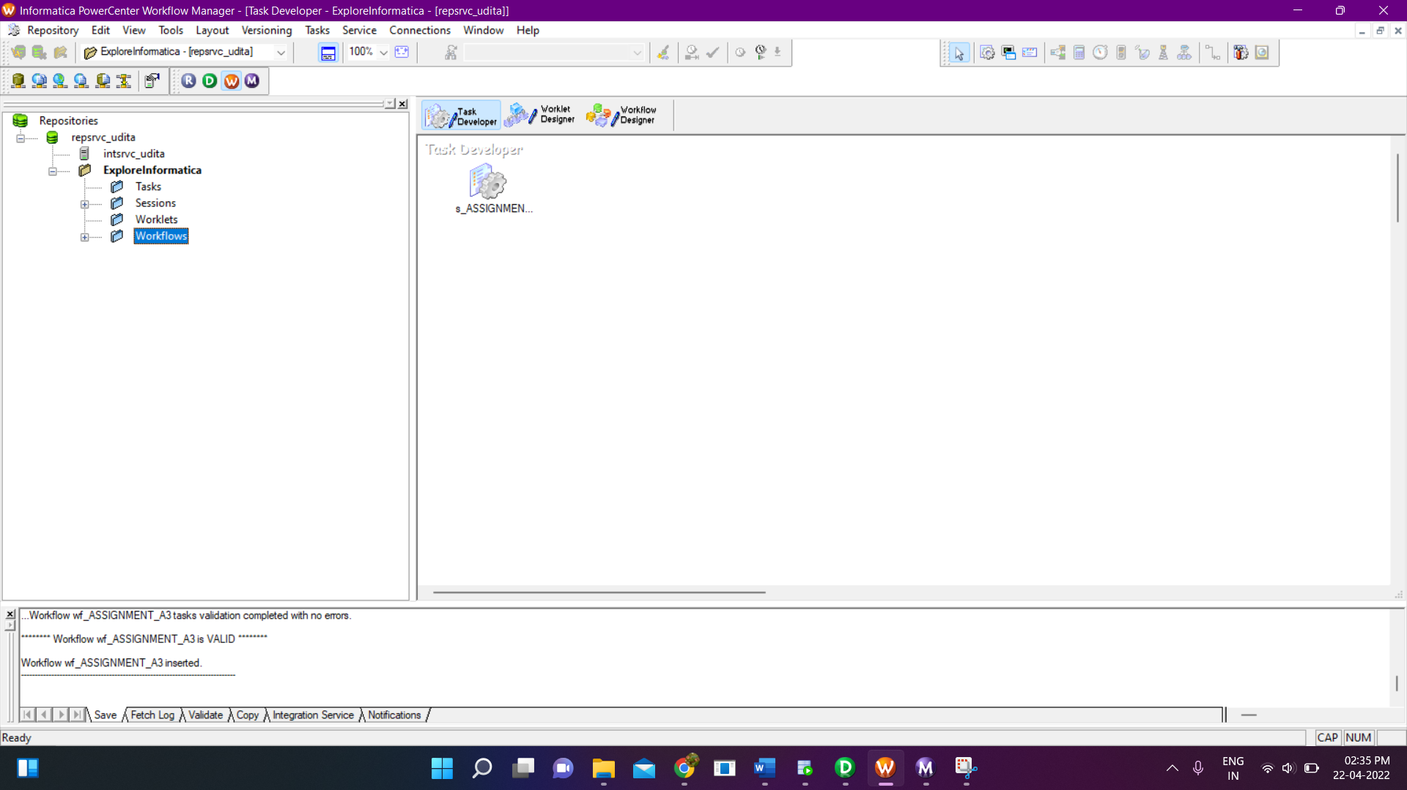

* Workflow:

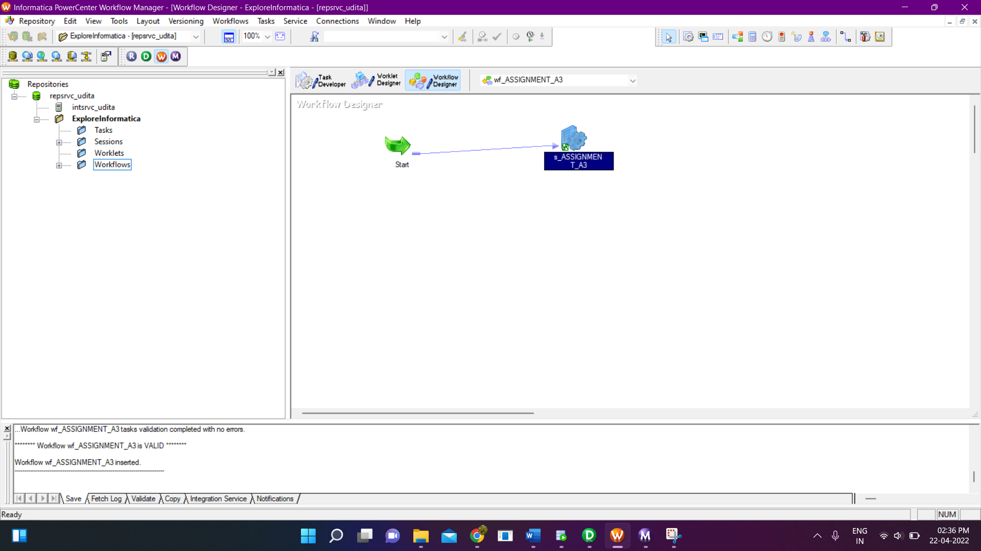

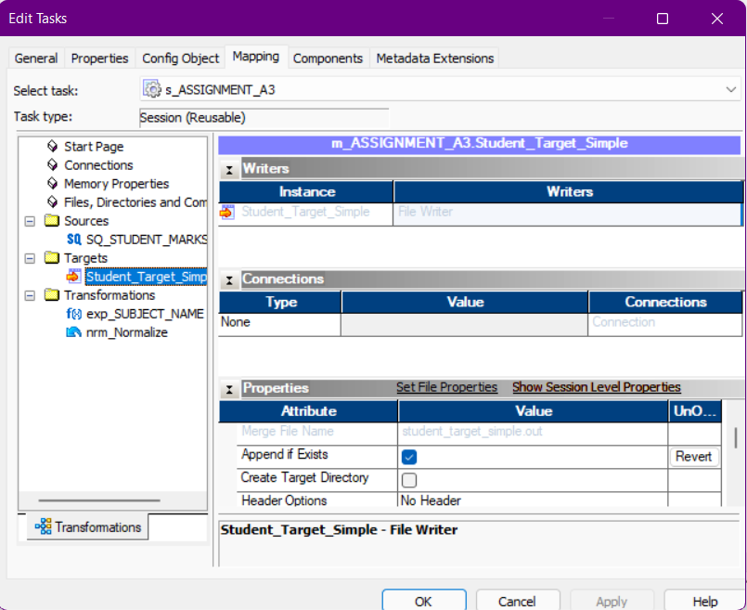

* Save all changes and Right click -> Start Worflow.

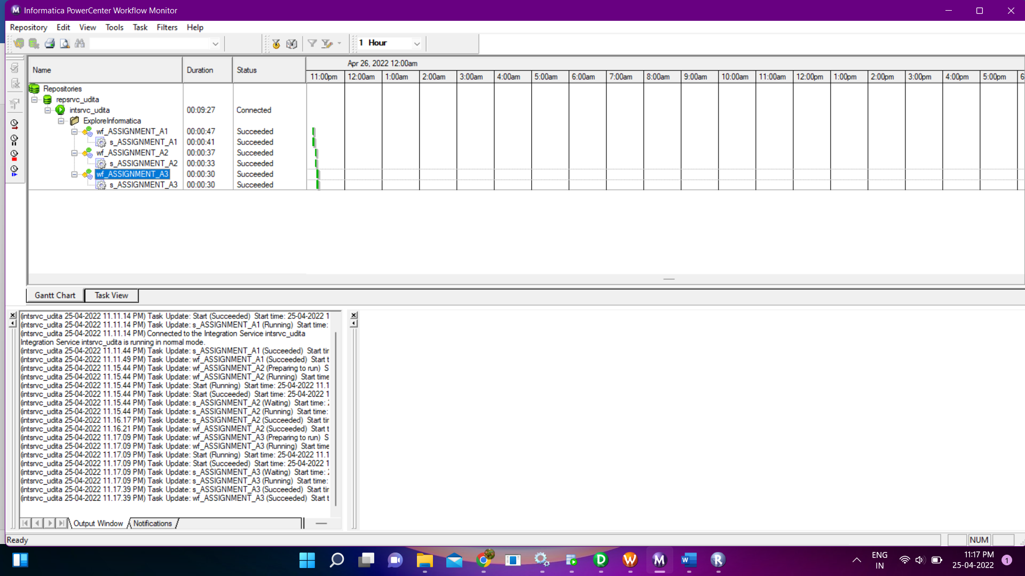

* Output:

